**Ridhima Joshi**

**Varshithanand Kotipalli**

SWEN5232 - Software Construction

Assignment Number:3

Professor: Dr. Findler

[findler@uhcl.edu](mailto:findler@uhcl.edu)

Teaching Assistant:

Shail Panchal

**Baking Cake**

**Requirements:**

1. Gathering all the ingredients for the cake.
2. Baking pan should be available.

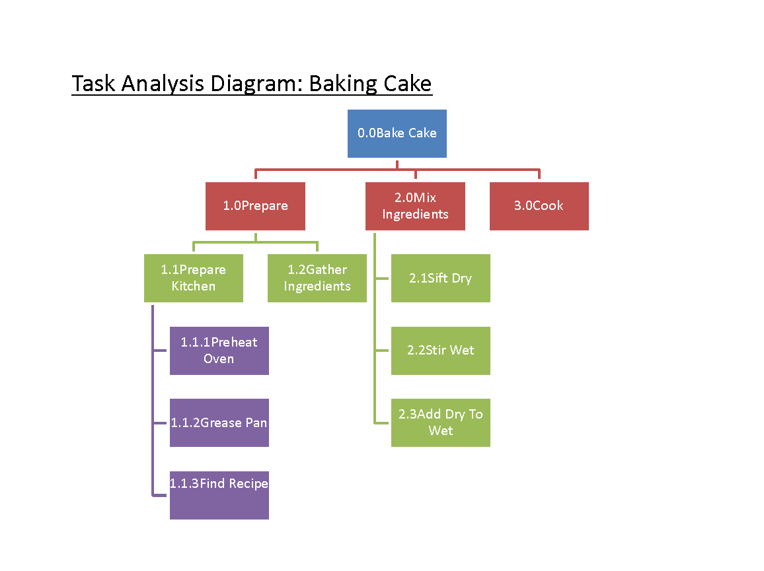

**Synthesized Use Case Diagram:**

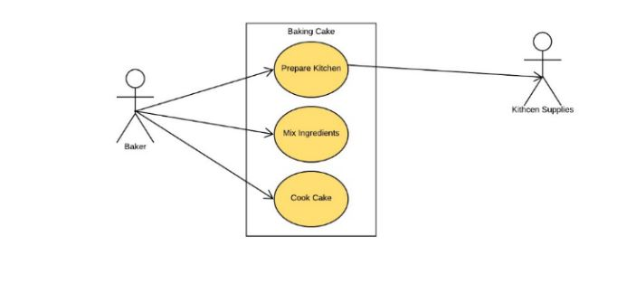

**0.0Bake Cake**

1. **What is the goal of this task?**

The goal of this task is to bake a cake.

1. **What subtasks define this task?**

The sub-tasks that define this task are

* 1. Prepare
  2. Mix Ingredients
  3. Cook

1. **Is this task a subunit of a larger task?**

No.

1. **What non-interface functions does this task require?**

No

1. **What kinds of inputs or actions does this task require from the user?**

The user should have a thought of baking a cake in his/her mind and have ingredients required in it.

1. **What kinds of outputs/results are expected by performing this task?**

The result expected is that Cake is baked.

1. **What automatic actions does this task expect from the system?**

No

1. **What special characteristics of this task should we record?**

None

1. **In this subtree, is there a task that must come before this one?**

No

1. **In this subtree, is there a task for which this one is required to be immediately preceding? Is there any specific sequence in which the tasks must be performed?** No
2. **Which, if any, primary classes/entities are involved in this subtask?**

Prepare, Mix Ingredients and Cook are the subtasks or primary classes of this task.

1. **How can this task fail (or end in non-completion)?**

This task can fail if the ingredients aren’t there or not cooked well.

1. **How frequently is this task performed?**

Whenever you feel like eating a cake.

1. **How open is this task, especially in terms of its sequence or inputs?**

This task is where we need to follow a recipe.

1. **What if any are the specific usability expectations (e.g. ease of use) for this task and how do we anticipate determining if we have satisfied the user expectations? (Hint: like ease of use, ease of learning. As you specify this, be specific as to what “ease of use” and other usability expectations mean and how you will evaluate these.)**

None

**1.2 Gather Ingredients**

1. **What is the goal of this task?**

The goal of this task is to get the ingredients required for baking a cake.

1. **What subtasks define this task?**

There are sub-tasks to define this task.

1. **Is this task a subunit of a larger task?**

Yes.

1. **What non-interface functions does this task require?**

No

1. **What kinds of inputs or actions does this task require from the user?**

The user should have all ingredients to bake or else needs to buy them.

1. **What kinds of outputs/results are expected by performing this task?**

The result expected is that all the ingredients are there to bake a cake.

1. **What automatic actions does this task expect from the system?**

No

1. **What special characteristics of this task should we record?**

None

1. **In this subtree, is there a task that must come before this one?**

Yes.

1. **In this subtree, is there a task for which this one is required to be immediately preceding? Is there any specific sequence in which the tasks must be performed?**

Yes

1. **Which, if any, primary classes/entities are involved in this subtask?**

No

1. **How can this task fail (or end in non-completion)?**

This task can fail if the ingredients are not there.

1. **How frequently is this task performed?**

Whenever you feel like eating a cake.

1. **How open is this task, especially in terms of its sequence or inputs?**

This task is where we need to follow a recipe.

1. **What if any are the specific usability expectations (e.g. ease of use) for this task and how do we anticipate determining if we have satisfied the user expectations? (Hint: like ease of use, ease of learning. As you specify this, be specific as to what “ease of use” and other usability expectations mean and how you will evaluate these.)**

None

**Coffee Shop Website**

**Requirements**:

1. Order the coffee.
2. Pay for the coffee after the order is placed.

**Task Analysis:**

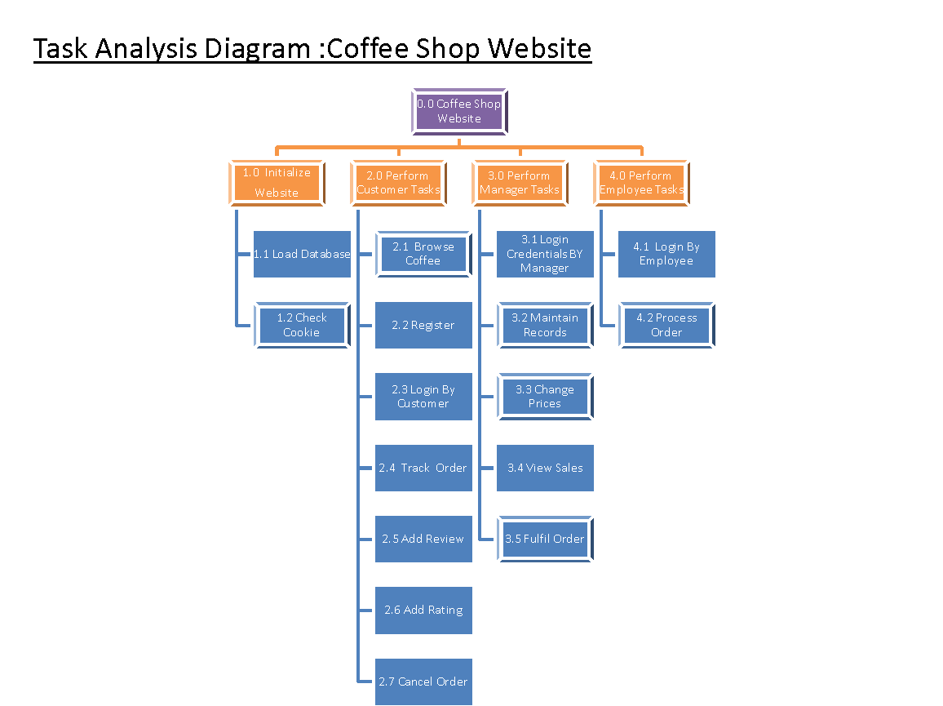

**Synthesized Use Case Diagram:**

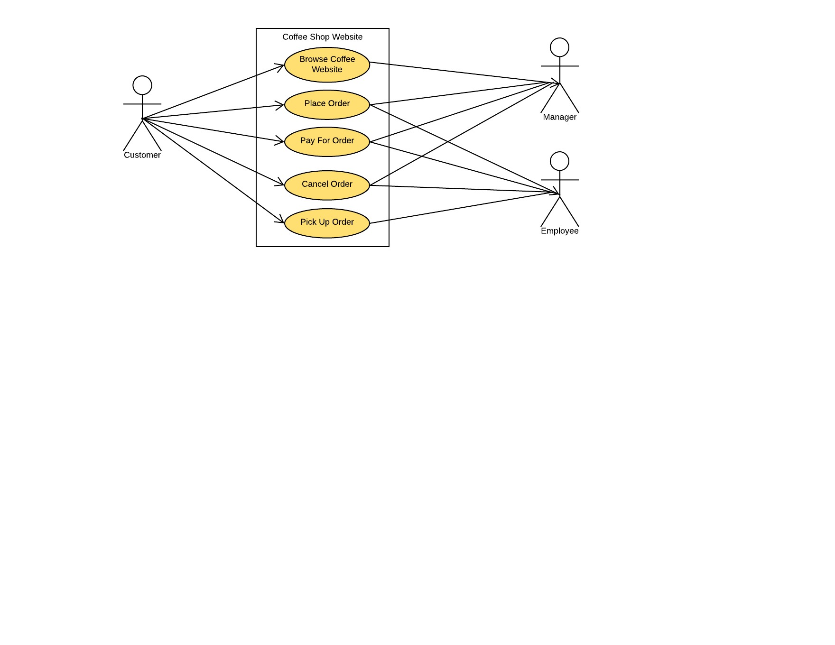

1. **Coffee Shop Website**
2. **What is the goal of this task?**

The goal of this task is to show up a website to buy coffee.

1. **What subtasks define this task?**

The sub-tasks that define this task are

* 1. Initialize Website
  2. Load Database
  3. Check Cookie
  4. Perform Customer Tasks

2.1 Browse Coffee

* 1. Register
  2. Login By Customer
  3. Track Order
  4. Add Review
  5. Add Rating
  6. Cancel Order
  7. Perform Manager Tasks

3.1 Login Credentials By Manager

3.2 Maintain Records

3.3 Change Prices

3.4 View Sales

3.5 Fulfil Order

* 1. Perform Employer Tasks

4.1 Login By Employer

4.2 Process Order

1. **Is this task a subunit of a larger task?**

No.

1. **What non-interface functions does this task require?**

No

1. **What kinds of inputs or actions does this task require from the user?**

The user should browse this website.

1. **What kinds of outputs/results are expected by performing this task?**

The result expected is that Coffee is bought.

1. **What automatic actions does this task expect from the system?**

No

1. **What special characteristics of this task should we record?**

None

1. **In this subtree, is there a task that must come before this one?**

No

1. **In this subtree, is there a task for which this one is required to be immediately preceding? Is there any specific sequence in which the tasks must be performed?** No
2. **Which, if any, primary classes/entities are involved in this subtask?**

Initialize website, perform customer tasks, perform manager tasks and perform employee tasks are the subtasks or primary classes of this task.

1. **How can this task fail (or end in non-completion)?**

This task can fail in many situations such as if internet connection is not available; the website not deployed properly, the performance not good the website might crash.

1. **How frequently is this task performed?**

Whenever user wants to visit website.

1. **How open is this task, especially in terms of its sequence or inputs?**

This task is open when website is accessed.

1. **What if any are the specific usability expectations (e.g. ease of use) for this task and how do we anticipate determining if we have satisfied the user expectations? (Hint: like ease of use, ease of learning. As you specify this, be specific as to what “ease of use” and other usability expectations mean and how you will evaluate these.)**

None

* 1. **Add Review**

**1. What is the goal of this task?**

The goal of this task is to add review for an item.

**2.What subtasks define this task?**

There are sub-tasks to define this task.

**3.Is this task a subunit of a larger task?**

Yes.

**4. What non-interface functions does this task require?**

No

**5. What kinds of inputs or actions does this task require from the user?**

The user should input the reviews..

**6. What kinds of outputs/results are expected by performing this task?**

The result expected is that review should be added.

**7. What automatic actions does this task expect from the system?**

No

**8. What special characteristics of this task should we record?**

None

**9. In this subtree, is there a task that must come before this one?**

Yes.

**10. In this subtree, is there a task for which this one is required to be immediately preceding? Is there any specific sequence in which the tasks must be performed?**

Yes

**11. Which, if any, primary classes/entities are involved in this subtask?**

No

**12. How can this task fail (or end in non-completion)?**

This task can fail if customer is not logged in.

**13. How frequently is this task performed?**

Whenever you feel to add the reviews.

**14. How open is this task, especially in terms of its sequence or inputs?**

This task is where is needed the customer to logged in.

**15. What if any are the specific usability expectations (e.g. ease of use) for this task and how do we anticipate determining if we have satisfied the user expectations? (Hint: like ease of use, ease of learning. As you specify this, be specific as to what “ease of use” and other usability expectations mean and how you will evaluate these.)**

None

**3.3 Change Prices**

**1. What is the goal of this task?**

The goal of this task is to change the prices.

**2. What subtasks define this task?**

There are sub-task that define this task is:

3.3 Change Prices

3.3.1 Offer Discounts

**3. Is this task a subunit of a larger task?**

Yes.

**4. What non-interface functions does this task require?**

No

**5. What kinds of inputs or actions does this task require from the user?**

The manager should login in the system.

**6. What kinds of outputs/results are expected by performing this task?**

The result expected is to change the prices of the items.

**7. What automatic actions does this task expect from the system?**

No

**8. What special characteristics of this task should we record?**

None

**9. In this subtree, is there a task that must come before this one?**

Yes.

**10. In this subtree, is there a task for which this one is required to be immediately preceding? Is there any specific sequence in which the tasks must be performed?**

Yes

**11. Which, if any, primary classes/entities are involved in this subtask?**

No

**12. How can this task fail (or end in non-completion)?**

This task can fail if not logged in.

**13. How frequently is this task performed?**

Whenever you there is a need to change prices.

**14. How open is this task, especially in terms of its sequence or inputs?**

This task is where we need to log in.

**15. What if any are the specific usability expectations (e.g. ease of use) for this task and how do we anticipate determining if we have satisfied the user expectations? (Hint: like ease of use, ease of learning. As you specify this, be specific as to what “ease of use” and other usability expectations mean and how you will evaluate these.)**

None

* 1. **View Sales**

**1. What is the goal of this task?**

The goal of this task is to view sales.

**2. What sub-tasks define this task?**

There are sub-tasks to define this task.

**3. Is this task a subunit of a larger task?**

Yes.

**4. What non-interface functions does this task require?**

No

**5. What kinds of inputs or actions does this task require from the user?**

None.

**6. What kinds of outputs/results are expected by performing this task?**

The result expected is that sales should be viewed..

**7. What automatic actions does this task expect from the system?**

No

**8. What special characteristics of this task should we record?**

None

**9. In this subtree, is there a task that must come before this one?**

Yes.

**10. In this subtree, is there a task for which this one is required to be immediately preceding? Is there any specific sequence in which the tasks must be performed?**

Yes

**11. Which, if any, primary classes/entities are involved in this subtask?**

No

**12. How can this task fail (or end in non-completion)?**

This task can fail if manager is not logged in.

**13. How frequently is this task performed?**

Whenever you feel to view the sales.

**14. How open is this task, especially in terms of its sequence or inputs?**

This task is where is needed the manager to logged in.

**15.What if any are the specific usability expectations (e.g. ease of use) for this task and how do we anticipate determining if we have satisfied the user expectations? (Hint: like ease of use, ease of learning. As you specify this, be specific as to what “ease of use” and other usability expectations mean and how you will evaluate these.)**

None